Welcome Fitness Directors and Club Managers

Thank you for your interest in our KUSHH!™ Training Seminar Series. This packet has all the information you need to get started.

We have enlisted the industries top presenters to make it easy for you to implement the KUSHH! ™ programs at your facility and will keep you updated as new programs evolve.

Please read the following information or call 1-404-405-5309 for questions regarding KUSHH!™ presentations at your facility. We are excited for you to enjoy the benefits of this extraordinary new exercise device as well as the energy and quality of a KUSHH!™ Training event.

Cheers,

Gin Miller
KUSHH!™ Educational Development Team

For Immediate Release August 2016
Gin Miller Fitness
Atlanta, GA

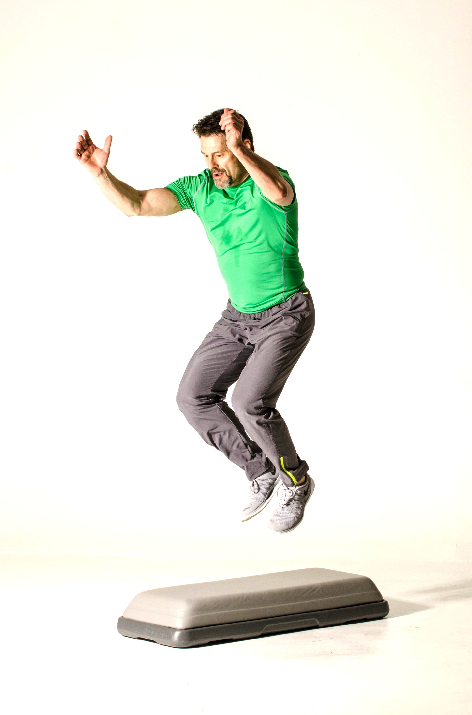
The Step Company and Gin Miller have been innovators in fitness for more than two decades, developing products that have disrupted the entire industry. Combining forces once again, they will soon unveil an extraordinary new exercise device called The KUSHH!™

KUSHH!™ is a unique new circuit workout system – a platform for cardio, a bench for strength training, a crash pad for plyometrics, a bed for PILATES, a lumbar support for CORE, a mat for Yoga and stretching and more – all in one device.

The KUSHH! ™exercise platform offers a rigid frame with a firm yet unstable surface that adds the functional elements of balance, coordination and stabilization to almost every exercise activity in every position. It allows the user an endless number of positions and applications that could otherwise be cumbersome or require multiple devices.

Says Ray Irwin, owner of The Step Company, “This is a unique evolution that far surpasses anything we have developed in years. The KUSHH!™ will accommodate a wide range of users, regardless of height, weight or shape. This is exciting news because the KUSHH!™ can be used in virtually every fitness and training environment.”

Gin Miller, who works closely with The Step Company to direct education and programming for the KUSHH!™ adds: “The KUSHH!™ provides a surface area that is unstable enough to increase energy expenditure and core engagement during almost any exercise, yet stable enough to perform compound movements and move quickly through integrated exercise sequences. It is a great tool for users from seniors to elite athletes.”

The Perfect ALL-IN-ONE Exercise Device
PLYOMETRIC CARDIO MUSCLE BUILDING SUPPORT SYSTEM
KUSHH!™ Softens the Landing, Ignites the Muscles, Fires the CORE.

“The most comprehensive, all inclusive device you’ll ever need.”
…Gin Miller, Inventor STEP AEROBICS.

Hosting A KUSHH!™ Workshop
(All fees include hourly rates plus expenses)

In-House Instructor Training
This workshop teaches your instructors the “KUSHH!™ Effect” in 8 hours. With Basic training in six different modalities, The National KUSHH!™ Training Team is available to provide your instructors with the tools they need to teach a fun and exciting series of classes on this new and innovative product.

Fees for a KUSHH!™ range from $750-$1000, depending on the trainer and the number of people attending. Fees range from $50-$100 per participant with a minimum of 15 attendees.

Regional Open Workshops
This type of workshop will give you the opportunity to host your own invitational event featuring a National KUSHH!™ Trainer. You can promote the event through social media as well as invite instructors from local clubs to attend. Profits for this kind of workshop range in the thousands if you can provide a large enough area to accommodate up to 60 instructors.

Fees for open workshops usually range from $50-100 per person, depending on the minimum number of people attending with a minimum of 15 attendees.

Master Classes
This is a great way to treat your members and instructors to a creative 90-minute workout featuring one of our prestigious trainers! It’s a special one day event that will energize and excite each attendee as well as set the tone for unveiling your club’s KUSHH!™ workouts. Each KUSHH!™ Specialty Master Class is $250 plus expenses and is listed on our website, www.ginmiller.com.

Personal Training
This one-on-one training is for the instructor who wants the benefits of a private session and can be easily accommodated with a 90-minute fee of $250 plus expenses. Call for details.

Conventions, Conferences and Symposiums
If you or your trade group wish to feature KUSHH! ™ at your event, please contact Gin Miller for details, ginmiller1@gmail.com, and 404-405-5309. Special rates are available for national and International appearances.

A Step-by-Step Guide for Booking your KUSHH! ™ Workshop

- Go to www.ginmiller.com and click on KUSHH! ™ Workshop Training.
- Choose a date, trainer and type of workshop and fill out the host facility form.
- Upon email confirmation of date and trainer availability, our staff, we will set up a time and day to call you and discuss specific details.
- KUSHH! ™ Trainer will contact you to discuss presentation, fees, travel, accommodations and other paperwork/handouts relating to the event.
- Mail your trainer a deposit if required.
- Coordinate the event with instructors attending workshop with the sample flyer which can be downloaded from our website for printing.
- Order KUSHH! ™ product(s) from the KUSHH! ™ store.
- Call and confirm product arrival and any last minute details before your event.
- Download Promotional Packet

Workshop fees
The KUSHH! ™ Global Training Team consists of our top trainers and presenters all over the globe. Their fees range from $125 per hour to $1500 for the day, (8 hours), depending on the trainer. Fees are not generally listed on the website due to travel time and geographical locations which may effect the typical charge. These fees do not include travel and expenses as each trainer may have different needs based on scheduling and location matters. We will be available by phone to discuss all fees and questions regarding each trainer’s requirements. As per confirmation of your workshop or event, our staff will send you downloadable packet contents for you to print for each participant including outlines and/or any other paperwork that may be included in the participant packet not provided by your trainer.

Transportation
Your trainer will be coordinating with you upon booking to help you arrange all travel to and from your workshop including but not limited to air and ground travel. Your trainer may charge the IRS travel $ per mile for driving and receipts for gas will be included with rental car obligations. Please provide a fly-in and fly-out itinerary which provides ample rest for trainers with long distances to travel and may include an over night stay at a hotel.

Overnight Accommodations
Accommodations should be arranged with your trainer according to his/her needs. Each trainer may have dietary or nutritional requests, which may require additional arrangements during the workshop break and afterwards. These requests are to be discussed and arranged prior to the workshop

Equipment Needs
If your club has ordered and received the KUSHH! ™ product, please contact us for special considerations as we may arrange a mutual workshop that is promoted through our website. KUSHH! ™ products ship individually or in volume and include an exercise poster and a link to a video demonstration of the product and we or your trainer will provide ACE and AFAA CECs, Evaluation forms, Workshop Outline and Injury Waivers. Workbooks can be downloaded and printed by each individual through a link provided. Even though your staff may be talented in their area of expertise, our trainers have concentrated their efforts on providing original and innovative programs as well as safe and effective exercise specific to the KUSHH! ™ for you to take advantage of.

Cancellation Policy
Each trainer will communicate his or her cancellation policy directly with you upon booking. However, it is our policy to provide a reasonable substitute trainer in the event of injury, illness, or act of God event.

KUSHH! ™ WORKSHOP REQUEST FORM

Today’s Date: ___________________

Host Facility Information:
Club Name: _______________________________
Club Street Address: ___________________________________________________________
City: ___________________________ State: _______ Zip: ____________
Contact Name: ___________________________ Title: _________________________
Contact Phone: __________________________
Email:______________________________________

Date(s) Requested: ____ /_____ /__________, ____ /_____ /__________, ____ /_____ /__________

Type of Workshop (see below): _____________________________________________

Trainer Requested: __________________________________________

Number of Anticipated Attendees: _____________________

Type of KUSHH Workshop:

- Introduction to KUSHH! ™ _____ Available Q1 2017
- KUSHH! ™ Strength _____ Available Q2 2017
- KUSHH! ™ Cardio _____ Available Q2 2017
- KUSHH! ™ Circuit Training _____ Available Q2 2017
- KUSHH! ™ PLYO_____ Available Q2 2017
- KUSHH! ™ CORE _____ Available Q2 2017
- KUSHH! ™ YOGA _____ Available Q2 2017

- Introduction to KUSHH! ™: __________ Available Q1 2017
This 8-hour workshop includes an introduction to the KUSHH! ™ product including layout options and class formats. The workshop will be broken down into 8 sections, featuring the multiple activity options for KUSHH! ™ in group exercise and personal training. Regarded as a “sampler” for each modality of fitness, this workshop will demonstrated and instruct KUSHH! ™ Cardio, Strength, Circuit training, PLYO, CORE and Yoga. This is our most popular workshop.

- KUSHH! ™ Strength: _________ Available Q2 2017
This unique strength workshop features new and exciting options for strength training in group exercise and one-on-one coaching. The dynamic surface of the KUSHH creates an assortment of new body positions accompanied by body mechanics that are otherwise inaccessible in traditional strength training classes. Featured are new integrated sequences that allow for greater range of motion and more muscle recruitment -- you’ll love the creative aspect of this workshop and enjoy the methodology for original new strength training exercises.

Please SCAN and email back 10 days prior to event to: ginmiller1@gmail.com or call to confirm: 404-405-5309,
- KUSHH! ™ Cardio: ___________ Available Q2 2017
THIS IS NOT YOUR MOTHER’S STEP! While step training alone has given way to circuit training and strength training on the platform, KUSHH! ™ is here to bring back climbing up and down on a raised platform! Experience the dynamic surface as you learn the basics of climbing, crossing and circumventing the KUSHH! ™ Simple movement champions this “back-to-basics” workshop, characterized by learning proper technique, form and alignment when performing cardio sequences on a dynamic surface. Safe and effective applications as well as terminology, set up and guidelines will be addressed in this fun and user-friendly workshop.

- KUSHH! ™ Circuit Training: __________ Available Q2 2017
Based on the most popular format of circuit training, Cardio-Resistance, this KUSHH! ™ Workshop will showcase the multi-functional convenience and versatility of this new and exciting “super step”. Experience the efficiency of fast and comfortable transitions that will allow participants to move quickly from one modality to the other without discomfort or difficulty. Teach movements that are otherwise impossible or cumbersome on multiple surfaces and enjoy learning the creative methodology behind original movements and application.

- KUSHH! ™ PLYO: ­­­­­________ Available Q2 2017
Explosive jump training using the KUSHH! ™ was the driving force behind the design of this amazing impact absorbing surface. The KUSHH! ™ PLYO workshop will teach you how to formulate sequences of explosive movements with reduced impact forces that cushion the landing for every participant. In addition, the dynamic surface increases muscle recruitment and coordinative balance challenges making this workshop an absolute necessity for interval training applications. Learn the most safe and effective ways to increase power, speed and strength with impact absorbing benefits that allow for deeper loading and softer landings.

- KUSHH CORE: __________ Available Q2 2017
CORE Galore and so much more is how you’ll feel after this workshop supplies you with multitudes of moves that center around the middle muscles. Because of the comfort of the KUSHH! surface, participants can position themselves in ways that allow for maximum range of motion and better body mechanics. Movements that increase MOBILITY and DYNAMICS take CORE exercises to a whole new level in this exciting, action packed workshop.

- KUSHH Yoga: __________ Available Q2 2017
This workshop focuses on the contemplative application of Yoga performed on the comforting surface of the KUSHH! Both the spiritual and physical discipline of Yoga transcends as participants use the elevated surface to enhance and challenge their best postures. Learn breathing techniques, timing and positional changes that will elevate you to a new level in your practice.

Please SCAN and email back 10 days prior to event to: ginmiller1@gmail.com or call to confirm: 404-405-5309,

KUSHH! ™ Host Facility Booking Form

Today’s Date: ___________________

Trainer Name: ______________________________________________

Workshop Location: (Club, City, State) __________________________________
____________________________
_____________________

Workshop Date: ______/_______/_____________
Workshop Name: ___________________________________________________
Number of anticipated participants: ____________________

Host Facility Information:
Club Name: _______________________________
Club Street Address: ___________________________________________________________
City: ___________________________ State: _______ Zip: ____________
Contact Name: ___________________________ Title: _________________________
Contact Phone: __________________________
Email: ______________________________________

Date(s) Requested: ____ /_____ /__________, ____ /_____ /__________, ____ /_____ /__________

Type of Workshop (see below): _____________________________________________
Trainer Requested: __________________________________________
Number of Anticipated Attendees: _____________________

ITEMS BELOW: The following can be purchased for individual sales on-site at the workshop or included in the price of the workshop to be used during the workshop. Each participant must have either a club KUSHH! to use or a pre-purchased KUSHH! to use, then take home.

Number of Manuals ordered at $15 each: _______________
Number of Music CDS ordered at $20 each: ________________
Number of KUSHH! ™ Platforms ordered at $150 each: ____________
KUSHH! ™ Training Kit (manual, music CD, KUSHH! platform) ordered at $175 each: _________

Who to be invoiced? ___________________________Email? ______________________________________________
(Please pay upon receipt)

------------------------------------------------FOR OFFICE USE ONLY--------------------------------------

Date received: _____/_____/__________
KUSHH! Rep: ________________________
Date materials shipped: ________________________Tracking number: _________________________________
Date received: __________________ Received by: ______________________________ Confirmed: ___________

Please SCAN and email back 10 days prior to event to: ginmiller1@gmail.com or call to confirm: 404-405-5309,
KUSHH! ™ Host Facility Workshop Prices

8 Hour Manual-Based Workshop | $1400 (plus $15 per manual per participant)
8 Hour Outline-Based Workshop | $1600
4 Hour Manual Based Trainings | $700 (plus $15 per participant)
3 Hour Specialty Class | $525
2 Hour Specialty/Master Class | $350
1 Hour Master Class | $175
2 Day Weekend training | $2800 (plus $15 per participant)

Each participant should have 40 square feet of space in and around the KUSHH! ™ platform.
To estimate the amount of room you will need for each participant, measure your room square footage capacity and divide it by 40. For instance, a room that measures 1000 square feet can comfortably hold 25 participants. A final count must be available 2 weeks prior to the event.

For all bookings, travel and expenses must be covered by the host facility. Discuss this with your trainer during the booking process.

All bookings require a 50% deposit no later than 2 weeks before the event. Deposits received later than 2 weeks from the event may result in late shipping charges for equipment or educational materials. Deposits are non-refundable if cancelled less than 30 days prior to the event.

KUSHH! ™ Host Facility Confirmation Form

Confirmation of workshop at ________________________________facility. Details below.

Date of Event: _____/_____/__________
Name of Event: _______________________________________
Time of Event: ________________________

Your Instructor information is listed below. If you have any questions or concerns, please contact them directly.

Your KUSHH! ™ Trainer is: ____________________________________________
Your KUSHH! ™ Trainer cell number is: ______________________________
Your KUSHH! ™ Trainer email is: _____________________________________

Your KUSHH! ™ Training deposit is due by: __________________________
Your KUSHH! ™ Training deposit is: __________________________________
(Written to your trainer or DBA)

KUSHH! ™ Host Facility Evaluation Form

It was our pleasure to bring you this exciting workshop today. We hope that you had a valuable learning experience and you found your trainer and the facility to be up to your standards of excellence. Please fill out the form below and give us your much-appreciated feedback, with 1 being the lowest score and 5 being the highest.

1. Was your contact person available and helpful?

1 2 3 4 5

2. Did the equipment and educational materials satisfy your expectations?

1 2 3 4 5

3. Was your trainer professional and timely?

1 2 3 4 5

4. Was your trainer knowledgeable on the subject matter?

1 2 3 4 5

5. How would you rate the quality of education today?

1 2 3 4 5

6. Would you recommend this workshop to others?

1 2 3 4 5

7. Please list comments or suggestions about this workshop.

Thank you for your participation.

